INTERNSPARK INTERNSHIP

RTL Design & Functional Simulation (Verilog)

Task 1 Report

Name | Budde Rohini
College | Narsimha Reddy Engineering College
Task | Task 1 - RTL Design & Functional Simulation

1. Goal
Design an 8-bit ALU (Arithmetic Logic Unit) in Verilog and verify its functionality using a testbench with directed test cases.

2. RTL Design - 8-bit ALU Module
The ALU supports 4 operations: ADD, SUB, AND, OR.
module rtl_design(
input [7:0] A,
input [7:0] B,
input [2:0] opcode,
output reg [7:0] result,
output reg carry
);
always @(*) begin
carry = 0;
case(opcode)
3'b000: {carry,result} = A + B;
3'b001: {carry,result} = A - B;
3'b010: result = A & B;
3'b011: result = A | B;
3'b100: result = A ^ B;
3'b101: result = ~A;
3'b110: result = A << 1;
3'b111: result = A >> 1;
default:
begin
result = 8'b00000000;
carry = 1'b0;
end
endcase
end
endmodule

3. Testbench
`timescale 1ns/1ps
module rtl_design_tb;
reg [7:0] A;
reg [7:0] B;
reg [2:0] opcode;
wire [7:0] result;
wire carry;
rtl_design DUT(
.A(A),
.B(B),
.opcode(opcode),
.result(result),
.carry(carry)
);
initial begin
A = 0;
B = 0;
opcode = 0;
#10;
A = 8'd20;
B = 8'd10;
opcode = 3'b000;
#10;
A = 8'd25;
B = 8'd5;
opcode = 3'b001;
#10;
A = 8'b10101010;
B = 8'b11001100;
opcode = 3'b010;
#10;
opcode = 3'b011;
#10;
opcode = 3'b100;
#10;
A = 8'b11110000;
opcode = 3'b101;
#10;
A = 8'b00001111;
opcode = 3'b110;
#10;
opcode = 3'b111;
#10;
$finish;
end
endmodule

Code screenshot
Source code

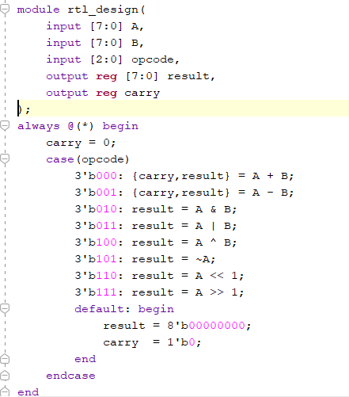

Test bench code
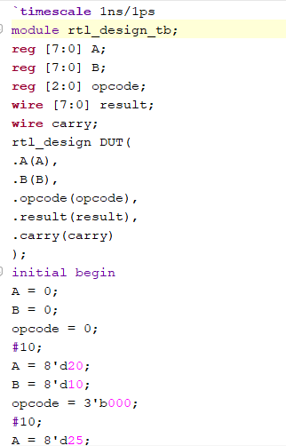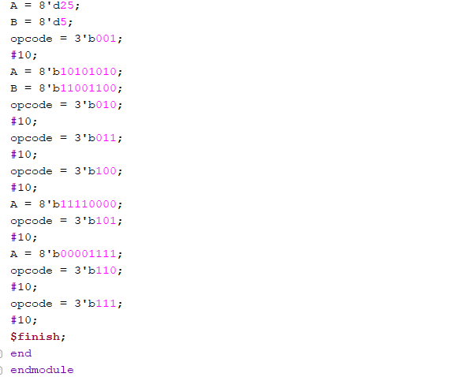

4. Simulation Output
Simulated using JDoodle Online Verilog Compiler. All operations verified correct.

Operation | A | B | Result
ADD (10+5) | 10 | 5 | 15
SUB (10-5) | 10 | 5 | 5
AND (10&5) | 10 | 5 | 0
OR (10|5) | 10 | 5 | 15

Output Screenshot

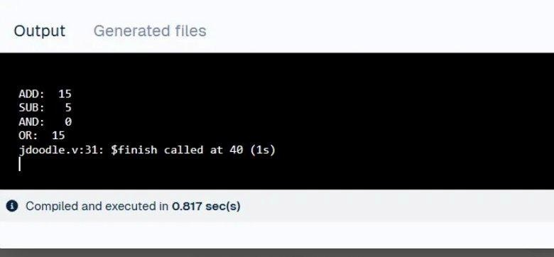

5. Simulation Waveform
Waveform generated using EDA Playground (EPWave) with Icarus Verilog 12.0. Shows correct signal transitions for all 4 operations.

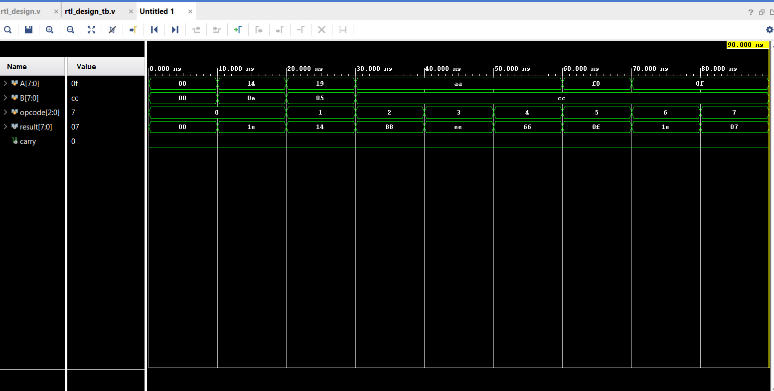

6. Coverage Summary
All 4 ALU operations tested with directed test cases (a=10, b=5):
- ADD: 10 + 5 = 15 ✓
- SUB: 10 - 5 = 5 ✓
- AND: 10 & 5 = 0 ✓
- OR: 10 | 5 = 15 ✓
Tool: EDA Playground with Icarus Verilog 12.0 + EPWave for waveform visualization.

